Visual Story: My visit to the Teece Museum of Classical Antiquities

### Follow this visual and written guide to help plan your visit to the Teece Museum.

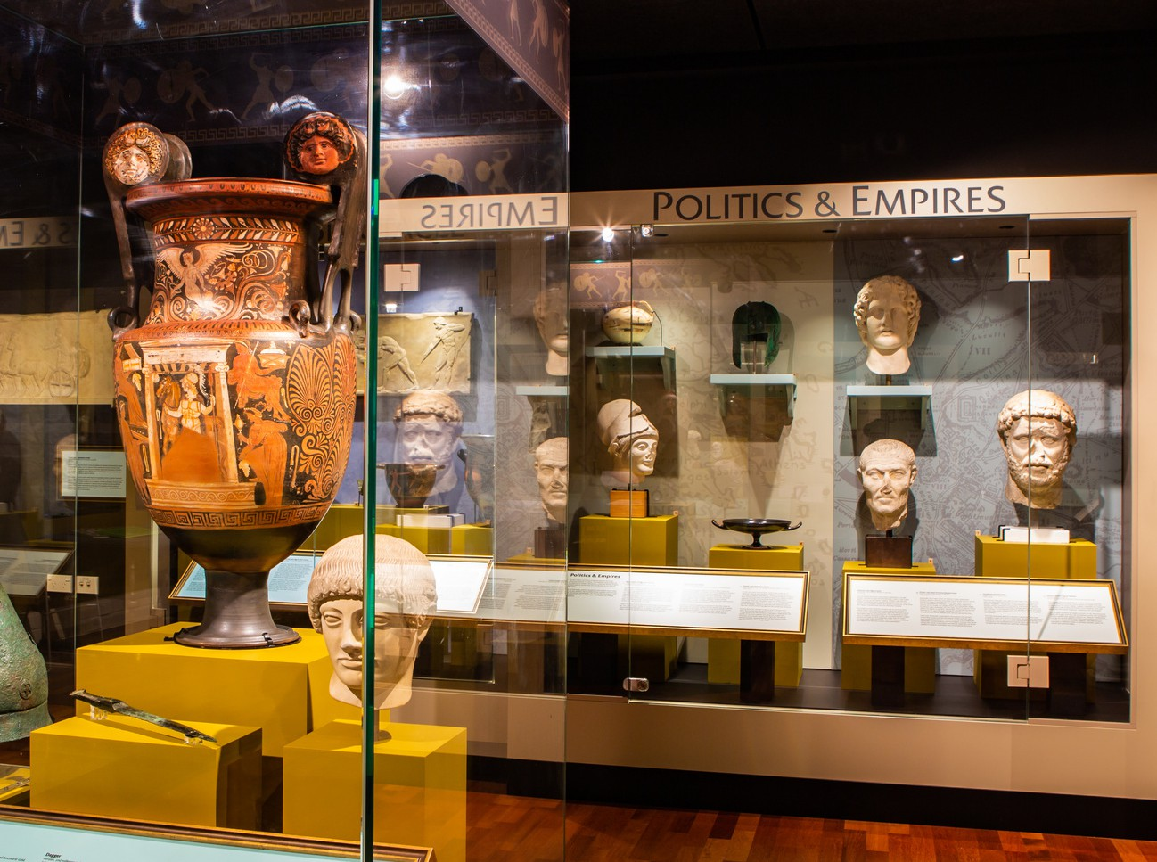



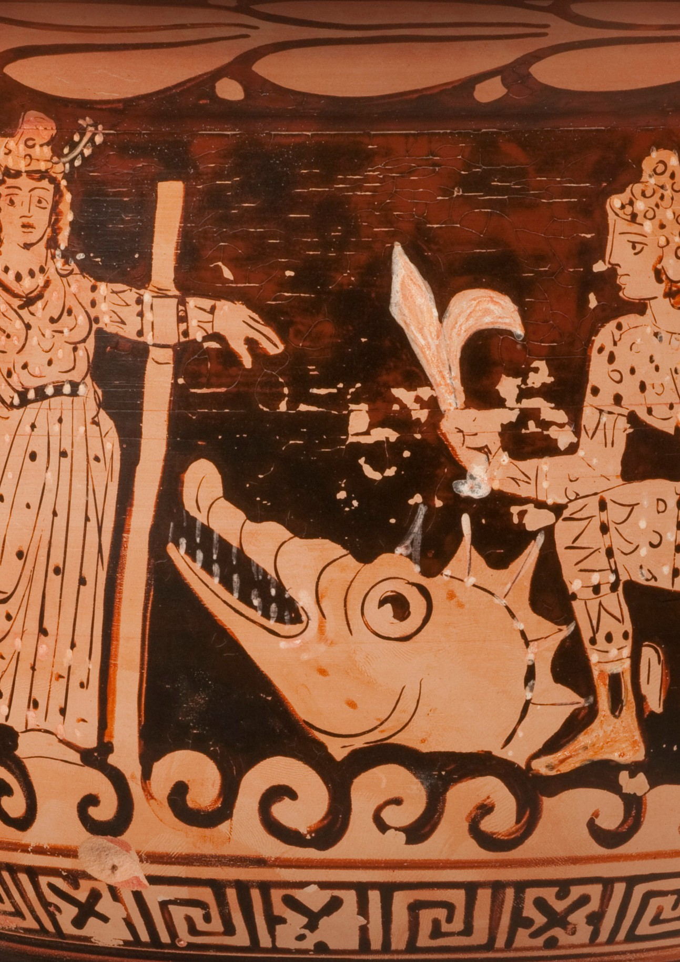

##### 2

**Contents**

I will be visiting the Teece Museum 4

Where can I find the Teece Museum? 5

Entering the Teece Museum: Accessible Entrance 6

Entering the Teece Museum: Front Entrance 7

The exhibition 8

Having a rest 9

Activities in the museum 10

Toilets 11

Places to eat 12

Exiting the museum 13

# The inside of the Teece Museum showing display cases with many different types of objects on display.I will be visiting the Teece Museum

I will use this Visual Story to prepare for my visit.

The Teece Museum is home to treasures from the ancient Greeks, Romans and Egyptians.

The Teece Museum is open from 11am-4pm Wednesday to Sunday. It is open seven days a week during the school holidays.

# The exterior of the Teece Museum with people sitting on the grass in front of the building.Where can I find the Teece Museum?

First I will go to the Christchurch Arts Centre where I will find the Teece Museum building in the South Quad.

I will know when I am there because I will see the stone building with the Teece Museum sandwich board outside.

The Teece Museum’s main entrance is located on the side of the building which faces the Arts Centre South Quad.

If I need to use the accessible entrance I will go to the other side of the building and enter via the glass doors.

To plan how I will get to the Teece Museum, I can go to the Visit page on the Teece Museum website.

# The accessible entrance to the Teece Museum.Entering the Teece Museum: Accessible Entrance

First, I will ring the doorbell and wait for a gallery host to come and help me.

The gallery host will open the glass doors for me and guide me to the accessibility lift which will take me to the first floor. The lift is noisy so I may want to bring my noise cancelling headphones in case I find it too loud.

Next the gallery host will take me around the corner and into the museum foyer. They will help guide me into the next lift, I may want to keep my headphones on as it will make a noise.

# Front entrance to the Teece Museum. Entering the Teece Museum: Front Entrance

First, I will walk up the steps to the entrance. The steps are old stone ones and a bit uneven; I need to walk carefully!

A gallery host will be sitting at reception to the left. I can ask them any questions I might have before I enter the gallery.

I will walk ahead and turn right towards the museum and enter the museum foyer. I will walk up two steps and turn left into the museum.

# The interior of the Teece Museum with mosaic of a hunting dog on the floor. The exhibition

When I first enter the museum a mosaic of a dog will greet me at the door. The mosaic is placed in the floor and covered with very strong glass. I can walk over the mosaic as it is safe to do so. I can also walk around the mosaic if I want.

A gallery host will be sitting at the front of the museum. They will greet me as I walk in, and I can ask them questions if I want to know more about something during my visit.

I can look at the objects in any order I like. If I would like to try a suggested route I can view the cases in this order:

1. People and Place
2. The Divine World 3.Mythological Heroes
3. Real Warriors
4. Greek and Roman Sport
5. Politics and Empire
6. Hearth and Home
7. Maidens to Mothers
8. Mythical Women
9. Special Exhibition case

# Interior of the Teece Museum showing one of the couches with books on it. Having a rest

If I need a rest while I am in the museum, I can take a seat on one of the couches in the middle of the room. The couches have books laid out on them which I can read if I want to.

I can also take a seat on one of the chairs at the front of the museum next to the gallery host.

# Game table in the middle of the Teece Museum. Activities in the museum

There are different activities I can try while I am exploring the museum. Some of the activities will change for the school holidays so I can ask the gallery host if I have any questions.

In the middle of the room is the Olympic Odyssey board game. I can compete against friends and family to see who will become the Olympic champion. Only four people can play the game at a time so I may need to wait my turn and explore something else while I wait.

On the light table in the back corner of the museum is an activity called Herakles is Hiding. I will need to find all the characters hidden in the scene. The characters I need to find are listed on the sides. I can compete with a friend or family member to see who can find their characters first. If the light table is too bright, I can ask the gallery host for a printed copy of the activity instead.

I can take turns having a go in the replica chariot and pretend to be a Greek soldier or an Olympian. Only one person is allowed in the chariot at a time so I may need to wait my turn. The chariot is not accessible to everyone so I may need to take part in the other activities instead.

There may be other activities available, such as the famous Teece Museum Lego Mini Figure hunt. These activity sheets will be placed on a stand near the museum entrance.

I can ask the gallery host if I have any questions about the activities.

# Three symbols: A toilet, a wheelchair user and a pair of hands being washed.Toilets

If I need help finding the toilet, I can:

 look for signs

 ask a gallery host

The closest toilet to the Teece Museum is to the right of the main lift, directly opposite the entrance to the museum foyer. These are all-gender toilets, and one is an accessible toilet.

The hand dryers are very loud. I can wear my noise cancelling headphones in the bathroom if I find the hand dryers too loud.

# Grassy area in front of the Teece Museum.Places to eat

I am not allowed to eat or drink in the exhibition spaces. This helps keep the displays safe and clean.

I can bring my own food and eat it outside in the South Quad or across the road in the Botanical Gardens.

There are lots of cafes around where I can buy food and drink.

# Inside of the front entrance to the Teece Museum looking towards the exterior courtyard.Exiting the museum

If I followed the suggested sequence in this Visual Story, I will have now explored the whole exhibition at the Teece Museum.

To exit the Museum, I will need to walk down the steps or use the lift and walk back out the main doors to the South Quad.

If I need to use the accessible entrance, I can ask one of the gallery hosts to help me and they will guide me to the accessible lift and back out to Hereford Street.

## We hope you enjoy your visit to the Teece Museum!

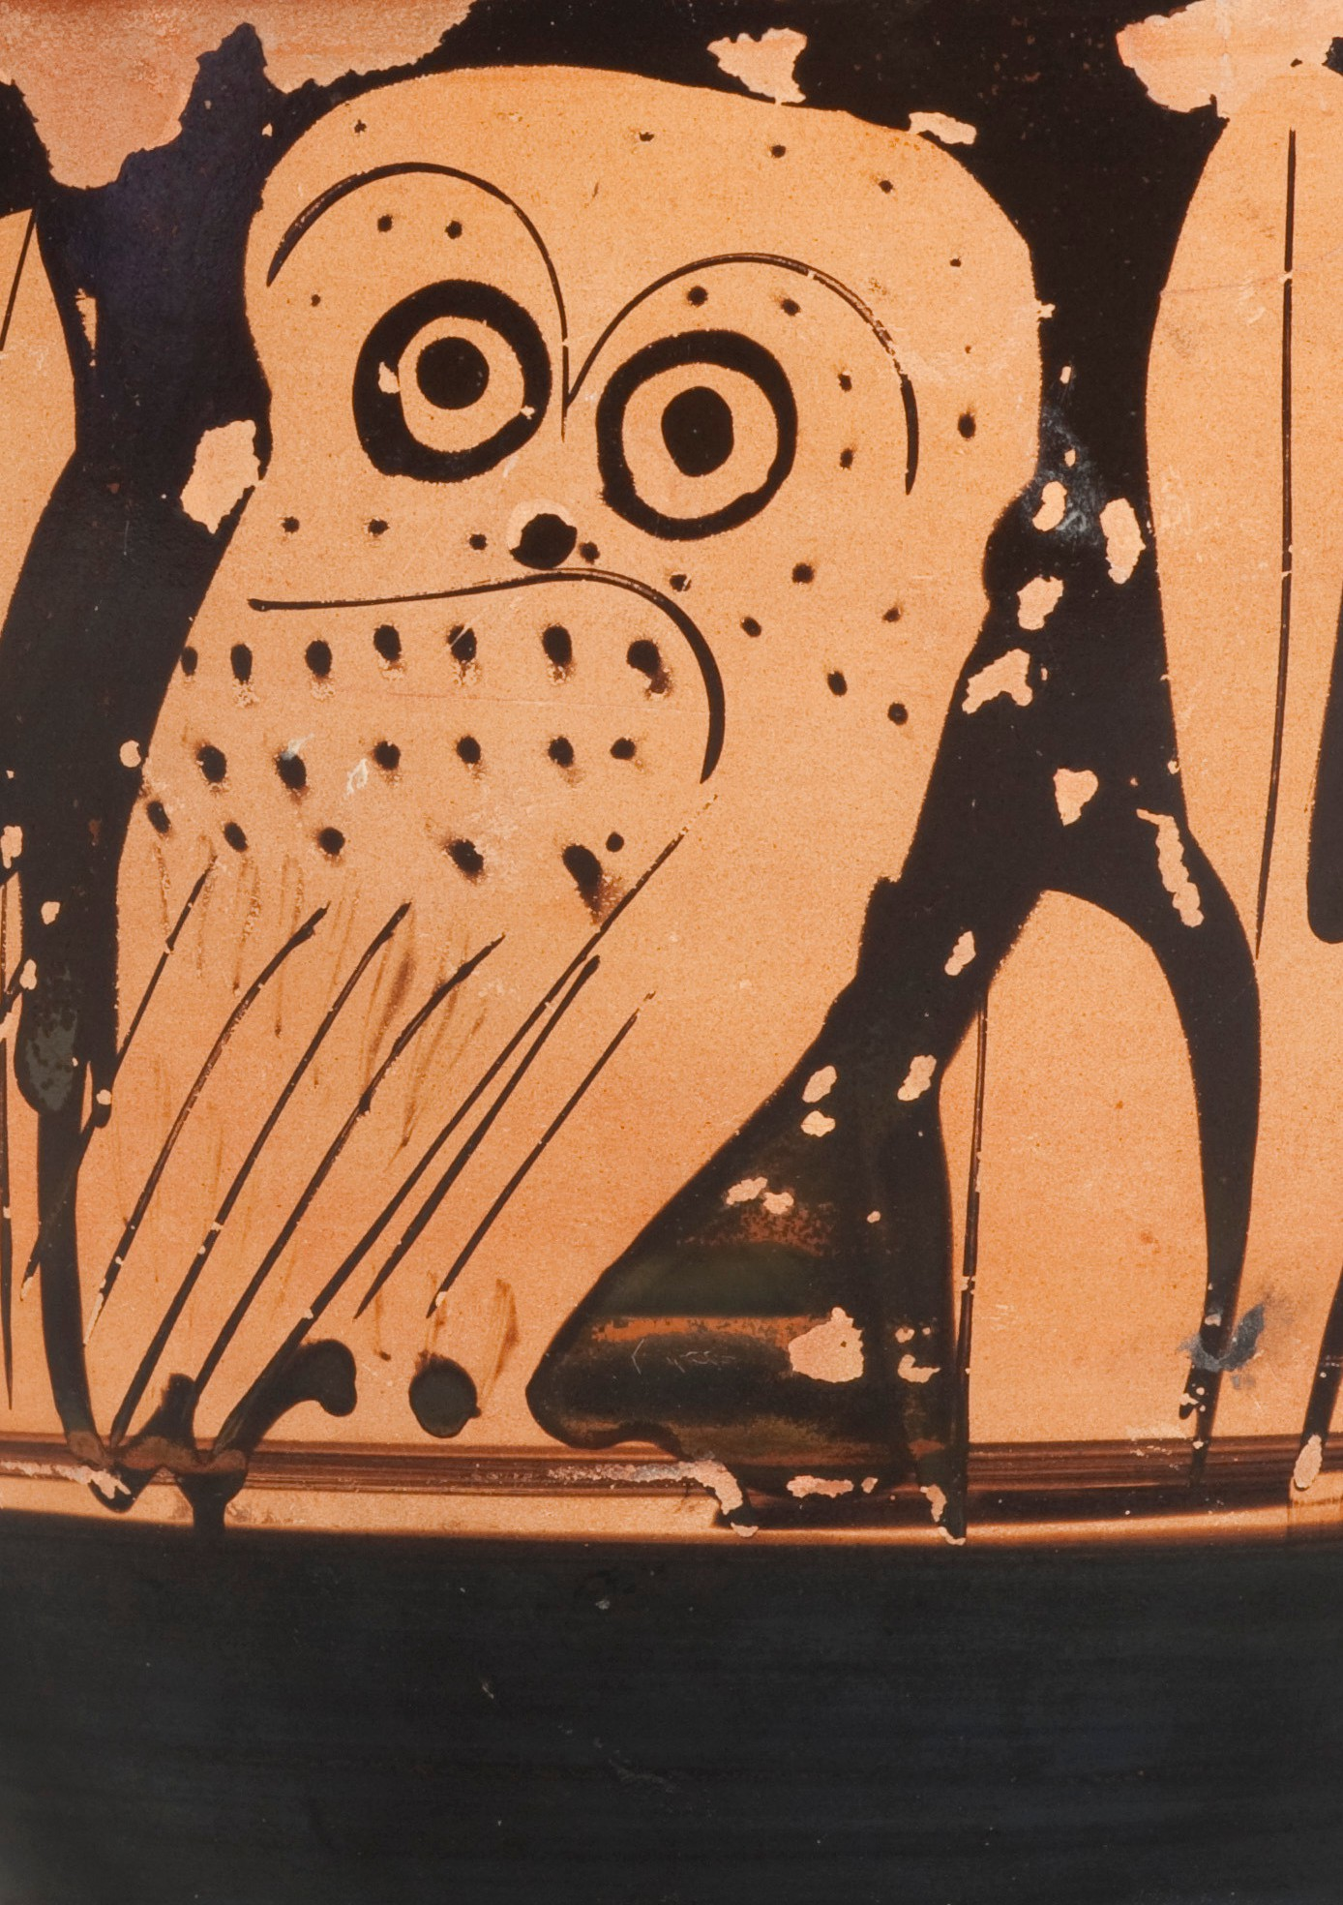

##### 15



#### [www.teecemuseum.nz](http://www.teecemuseum.nz/)

